Faculty Advisor
Manual

Fall 2016

ADVISING PHILOSOPHY STATEMENT

Advising at the Labovitz School of Business and Economics (LSBE) is an important component of the commitment to a quality undergraduate experience for students. The academic advising of the School is embedded in the campus advising and counseling system, drawing upon the resources available from outside of the School and working collaboratively within the campus system where appropriate to do so. Academic advising within LSBE is consistent with the mission of the School, concentrating on efforts most complementary to its unique role on the campus.

Advising helps students identify academic, career and life goals, and explore possible courses of study that they can pursue to achieve those goals, as appropriate to their interests, skills, abilities and values. Through the advising and counseling processes, students may make a critical connection to the School and the campus. Students also learn the policies and procedures of the university, and the nature, variety, and purpose of courses and requirements.

Participants in the advising and counseling system seek to establish a concerned, open relationship with students, helping them adjust to the social and academic environment of the School and of the university while they pursue the courses of study that match their interests and abilities. Campus-level units in the system provide students with opportunities to develop self-understanding and self-acceptance. Advising can play a key role in assisting students to achieve academic success and to become productive citizens as they mature intellectually, personally and socially.

Advising is an active and mutually reinforcing relationship between student and university participants in the advising/counseling system. Successful advisement can only be achieved if each party assumes responsibility for his or her role in that relationship.

LSBE ADVISING OBJECTIVES

As an academic unit with specific program objectives, the LSBE advising system concentrates on students’ academic concerns and progress appropriate to management education. While advising is currently not mandatory for LSBE students, they are strongly encouraged to make full use of the many advisement opportunities offered by the School and by other units within the campus system.

The primary objectives are:

● Provide opportunities for students to obtain assistance in the formulation of an educational plan consistent with their goals and objectives. (This would include the selection of majors, possible minors, and desirable elective courses.)

● Provide feedback to students regarding progress toward established goals and educational plans and opportunities to evaluate or re-evaluate those goals and plans.

● Make accurate and timely information about institutional policies, procedures, resources and programs available to students.

In order to achieve these objectives, an on-going training of peer and faculty advisors, along with an information dissemination program, will be maintained. In addition, periodic assessments of advising services will be conducted in order to determine if the above objectives are being met.

Note: For the development of the advising philosophy, the initial sub-group on advising consulted materials previously developed by the National Academic Advising Association and the American College Testing Program, revising them as appropriate to the campus and the School.

Passed by the LSBE Senate on May 11, 1998

ADVISING - A MUTUAL ENDEAVOR

The LSBE Advising Philosophy Statement describes advising as an active and mutually reinforcing relationship that requires each participant to assume the responsibilities appropriate to their role within the relationship. To assist participants, the following may be helpful:

RESPONSIBILITIES OF THE STUDENT ADVISEE

1. To contact your advisor when you want or need assistance. You need to find out when your advisor is available and take the initiative to make appointments. Your advisor may help you with planning the completion of your degree requirements (and will have to approve your graduation plan) and the scheduling of courses that help fulfill your requirements. However, your advisor is an expert in his or her field, someone who can assist you with more than simple course planning. Meet with your advisor about career issues and effective ways to prepare yourself for job seeking or about graduate/professional study. Your advisor is someone who can help you think more deeply about issues in your field and about your personal goals.

2. To learn university and collegiate degree requirements, policies and procedures. Read the materials provided - for example, the official catalog, the LSBE worksheets and major flyers, and the class schedule. You need to know how to help yourself by being knowledgeable about requirements and policies, course pre-requisites or other procedural issues, as you are ultimately responsible for your registration decisions and for fulfilling degree requirements. You will then be able to ask questions when you do not understand and to make the best use of your advisor's time with you.

3. To do some thinking and work ahead of time. It may help if you can clarify and communicate your personal goals and values, and if you have done some preliminary thinking or researching of career directions. If you are having academic difficulty, be prepared to discuss this honestly, before there are larger problems.

4. To come prepared for and keep your scheduled appointments. Bring the forms or materials you need, including a pen or pencil to take notes. Give some thought to what you want to accomplish when you meet with your advisor. You may even wish to write your questions and concerns down so you do not forget. If you cannot keep your appointment, please follow common rules of courtesy and notify your advisor as much in advance as you can.

5. To recognize that this is your education and that you are the one to make the decisions about your life. In the end, you must make the decisions and accept the responsibility for them. Your advisor's role is to assist you with the decisions by making suggestions or sharing information, not to decide for you. It will be you who must fulfill all degree requirements and successfully complete your classes.

6. To change your advisor if this relationship is not working for you. You may do so by completing the appropriate change of advisor form in LSBE Student Affairs. Your requested new advisor must be a faculty member in the major field you have selected.

RESPONSIBILITIES OF THE FACULTY ADVISOR

1. To provide students with reasonable and convenient access to their advisor. This involves a) posting and consistently maintaining a reasonable number and day/hour mix of office hours for students and
b) responding to questions and concerns via E-mail or telephone in a timely manner. This also implies that ordinary rules of courtesy apply if you cannot keep the appointment.

2. To create an "atmosphere" that facilitates open communication and promotes confidence and trust. Effective advising is predicated on treating advisees respectfully and demonstrating an appropriate level of personal interest in the intellectual, social, and emotional growth of students.

3. To be knowledgeable about the university and collegiate purposes and requirements, particularly those that relate to a student's major field of study, and to possess adequate and accurate information about academic policies and procedures. Advisors need to know the philosophy and rationale for the requirements, as well as the details of how it all fits together. An advisor often serves as the major source and interpreter of information about such matters for students. An advisor also needs to know how to obtain information or appropriate referral sources for students to find this information.

4. To be informed of the resources available within the university community. An advisor may need to refer students to a variety of campus services to help them achieve their goals and meet their academic, career and emotional needs. LSBE advising is embedded in a campus advising and counseling system. As such, it is not expected that each individual advisor be an expert in all areas; it is important that each know when and how to refer appropriately.

5. To maintain or access a current academic file on each advisee for the purpose of helping students to develop realistic and appropriate academic and career goals. The advisor should review the advisee's file, paper or electronic, prior to or when meeting with a student so that any discussion of course selection, planning for graduation or other academic and career issues is relevant to the established record.

6. To have a working knowledge of current career or graduate/professional school opportunities related to the faculty member's discipline. An advisor assists a student with identifying career goals and objectives. To do so, an advisor may have to ask questions, probe, help consider alternatives, encourage, support - and even challenge thinking. This may involve suggesting minors, specific courses or other types of activities that support the student's goals. Advisors may also need to refer students to other campus resources for assistance.

7. To gain knowledge and skills to work with special student populations. While each individual student presents some kind of unique circumstances, there are particular issues faced by a variety of special populations. Examples might be transfer students, non-traditional students, international students, students with disabilities, etc. Knowledge of specific campus resources relevant to each population is a foundation for providing appropriate guidance.

Passed by the LSBE Senate on 11/8/02

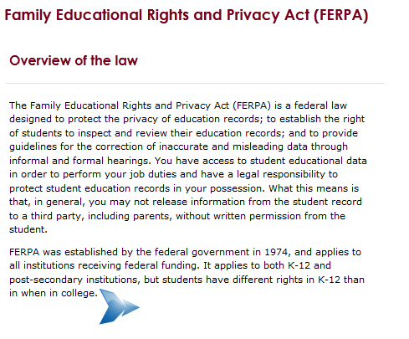

If you are unsure about releasing information, get in touch with:
Carla Boyd, Registrar
clboyd@d.umn.edu
(218) 726-8795
184 Darland Administration Building

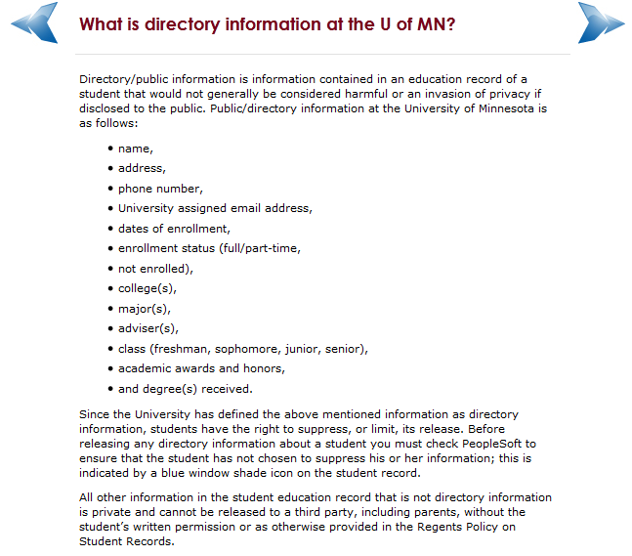

FERPA Compliance – Basics

- Be aware of FERPA. It is not necessary for faculty and staff to understand every nuance of FERPA and its administration. It is critically important that they understand that it exists and governs much of what they do.
- Be aware that FERPA is everyone’s responsibility. Faculty and staff must understand that every employee of every higher education institution can subject the entire school to FERPA liability, if s/he has access to student education records.
- Understand that almost all student records are subject to FERPA. Faculty and staff have access to lots of student records. Teachers often believe that only “academic records” are subject to FERPA. They sometimes believe that they have the authority to decide whether records fall under the law, or not. In fact, the law itself defines student records, and the definition is very inclusive.
- Disclosure of student records without student consent risks a violation of the law. Although FERPA provides for the disclosure of student records without consent to certain designated persons, or under certain specific circumstances, those exceptions are few and narrowly defined.
- Students have the right to see their records. FERPA requires all custodians of student records to accord review of those records to the specified student under almost all circumstances. Schools and school employees are not accorded the prerogative of deciding whether students should see records about them.
- The right of school employees to access student records is very narrow. FERPA accords school employees the right to view student records under certain circumstances, referred to as “legitimate educational interest.” In general, this means “the employee needs access to the records to do his/her job.” Curiosity is not a legitimate educational interest. The ability to access student records does not confer the right to view student records.
- Good intentions, common sense, or innocent mistakes do not mitigate privacy violations. Most FERPA violations by faculty and staff are unintentional. Nonetheless, it is the responsibility of the school to prevent violations and intent is not a defense.
- Ask for help! Faculty and staff are expected to be experts in their fields. They should expect their schools to support them with resources in the field of student records privacy. When they see a sign and they are not sure what it means, they are professionally responsible to find out before they drive by it!

Student Reference Request Consent Form

Student nam e (print):
I request to serve as a reference for me. The purpose(s) of the reference are: (check all applicable spaces)
_____ application for employment
_____ all forms of scholarship or honorary award
_____ admission to another education institution
The reference may be given in the following form/s (check one or both spaces):
_____ written _____ oral
I authorize the above person to release information and provide an evaluation about any and all aspects of my academic and/or employment performance at the University of Minnesota Duluth to the following (check all applicable spaces):
1. | _____ all prospective employers | OR | _____ specific employers (list on reverse side)
2. | _____ all educational institutions to which I seek admission | OR | _____ specific educational institutions (list on reverse side)
3. | _____ all organizations considering me for an award or scholarship | OR | _____ specific organizations (list on reverse side)
This authorization to provide references is valid for one (1) year from the date of my signature below, unless I specify an earlier ending date as follows:
Ending date: ___________________________
Note: Under the Family Educational and Privacy Rights Act, 20 U.S. C. 1232(g), you may, but are not required to, waive your right of access to confidential references given for any of the purposes listed on this form above. If you waive your right of access, the waiver remains valid indefinitely.
_____I waive my right of access

___________________________________________________ | __________________________
Signature | Date

Business and Accounting Minors
For BAcc and BBA Degree Students

Students should apply for these minors in LSBE 111A at the time they apply for candidacy. Admission criteria for the minors mirror that of candidacy. Students are admitted to the minor when they are in progress of completing the lower division pre-major requirements and if their overall and U of M GPAs are 2.60 or higher, and LSBE and Pre-Major GPAs are 2.00 or above.

Accounting
Required Courses (6 cr)
ACCT 3101 3.0 cr
ACCT 3301 3.0 cr
Electives (6 cr)
Take 2 courses totaling 6 credits from the following:
· ACCT 3102 3.0 cr
· ACCT 3401 3.0 cr
· ACCT 3201 3.0 cr
Economics
Required (3 cr.):
Econ 3022
or Econ 3023

Upper Division Electives (9 cr.):
Econ 3xxx/4xxx

Entrepreneurship
Required (9 cr).
Blaw 3201 3 cr.
MgtS 4472 3 cr.
MgtS 4921 3 cr.

Electives (3 cr.)
MgtS 4443 3cr.
MgtS 4473 3 cr.
Mgfts 4475 3 cr.
MgtS 4931 3 cr.
MgtS 4941 3 cr.
MgtS 1951 3 cr.
Mktg 3721 3 cr.
Mktg 4741 3 cr.

Finance
Prerequisite:
FMIS 3601 3.0 cr
Required (6 cr)
FMIS 3644 3.0 cr
FMIS 3647 3.0 cr
Finance Minor Elective (3 cr)
Take 3 credits from the following:
· FMIS 3612 3.0 cr
· FMIS 3619 3.0 cr
· FMIS 3649 3.0 cr
· FMIS 3655 3.0 cr
· FMIS 4615 3.0 cr
· FMIS 4617 3.0 cr
· FMIS 4644 3.0 cr

Health Care Management
Core Minor Courses (9 cr)
ECON 3910 3.0 cr
HCM 4520 3.0 cr
HCM 4530 3.0 cr
Electives (6 cr)
Take 6 credits from the following:
· FMIS 4220 3cr.
· HCM 4510 3.0 cr
· HCM 4550 3.0 cr
· HCM 4560 3.0 cr
· HCM 4570 3.0 cr
· HCM 4595 3.0 cr
· HCM 4597 3.0 cr
· INTB 4221 3.0 cr

International Business
Group A (9 cr): Take 3 courses from the following:
Acct 4505 3 cr
FMIS 3649 3 cr
MgtS 4474 3cr
MgtS 4861 3 cr
Mktg 3781 3 cr

Group B (3 cr)
Take 1 course from the ollowing:
Econ 3150 3 cr
Econ 3402 3 cr
Econ 4410 3 cr
HCM 4560 3 cr
INTB 3xxx/4xxx 3 cr

Management Information Systems
Group A Requirement (6 cr)
FMIS 3220 3.0 cr
FMIS 3222 3.0 cr
Group B Requirement (6 cr): Electives
Take exactly 6 credits from the following:
· FMIS 3224 3.0 cr
· FMIS 3232 3.0 cr
· FMIS 4220 3.0 cr
· FMIS 4221 3.0 cr

Marketing
Prerequisite:
MKTG 3701 3.0 cr
Electives
Take 9 credits from the following:
· MKTG 37XX
· MKTG 47XX
· NOTE: Mktg 3701, 3761, 3767, 4762, and 4763 may not be used to fulfill the electives requirement.

OVER

Management
Group A- required
MgtS 3401 3cr

Group B- electives (9 credits)
**Select 3 courses, one from each of the three areas listed below:
*MgtS 4495 Special Topics may fulfill one of these areas – by petition only

Macro Org Behavior:
MgtS 4411 3.0 cr
MgtS 4421 3.0 cr
MgtS 4483 3.0 cr

Micro Org Behavior:
MgtS 4431 3.0 cr
Mgts 4441 3.0 cr
MgtS 4443 3.0 cr
MgtS 4451 3.0 cr

Mgmt and Mgmt Process:
MgtS 4461 3.0 cr
MgtS 4472 3.0 cr
MgtS 4473 3.0 cr
MgtS 4474 3.0 cr
MgtS 4475 3.0 cr

Human Resource Management
Group A- required
MgtS 3801 3cr

Group B- electives (9 credits)
MgtS 4821 3.0 cr
MgtS 4831 3.0 cr
MgtS 4841 3.0 cr
MgtS 4851 3.0 cr
MgtS 4861 3.0 cr
MgtS 4881 3.0 cr
MgtS 4895 3.0 cr

Special Admission Minor Programs
For any of the minors below, students need to submit an application and be selected into the minor by the program director.

Financial Markets
Required Pre-Requisites (9 cr.)
FMIS 3601 3 cr.
FMIS 3619 3 cr.
FMIS 3644 3 cr.

Required courses (9 cr.)
FMIS 4616 3 cr.
FMIS 4620 3 cr.
FMIS 4624 3 cr.

Financial Planning
Required (24 cr.):
Acct 2001 3 cr.
Acct 3401 3 cr.
Acct 4600 3 cr.
Blaw 3301 3 cr.
FMIS 3601 3 cr.
FMIS 3644 3 cr.
FMIS 3655 3 cr.
FMIS 4646 3 cr.

Marketing Analytics
Required (21 cr.):
Mktg 3701 3 cr.
Mktg 3711 3 cr.
Mktg 4731 3 cr.
MKtg 3761 3 cr.
Mktg 3767 1 cr.
Mktg 4762 3 cr.
Mktg 4763 2 cr.
FMIS 3220 3 cr.
Econ 4040 3 cr.
or Stat 5411
or Stat 5511

Revised: 8/19/2016

LSBE WAITING LIST PROCEDURES

LSBE courses utilize the online waiting list system. There are some exceptions, such as internships and independent studies, which require instructor consent. Some non-LSBE classes on campus do not utilize wait lists, so check with other departments or colleges about their wait list procedures.

How to add yourself to the online wait list?

- Verify that you have completed the proper course pre-requisites. If you have not met all pre-requisites, you will not be able to add yourself to the waiting list.
- If a class you really need is closed, and you meet the pre-requisites, add yourself to the wait list in the same way you would add yourself to any class. On the enrollment preferences page, simply click the Add to Wait List box. The courses you wait list for will appear on your enrollment summary.

What happens once you are on the wait list?

- Advising Office Staff will prioritize students (see below) who put themselves on the waiting list during the registration period. Note: Students who wait list AFTER the registration period will stay on the list in date order.
- LSBE faculty and staff WILL NOT give out information on wait list positions; please do not ask.
- If a seat becomes available, the registration system will attempt to put the first student on the waiting list into the class. If the attempt is successful, the student will receive an e-mail stating they got into the class. If there was a problem that prevented the student from getting into the course, the system will send an e-mail stating the problem and then move on to the next student on the waiting list.
- If you are registered for a course that is a time conflict with a wait listed course, then make sure you set up your wait list request to process as a swap (drop current class, if enrolled in wait listed class). Or, if adding your wait list class puts you over 20 credits, then determine which class is least important and set up your wait list request to process as a swap (drop current class, if enrolled in wait listed class).
- If you are still on a waiting list when the term begins and still want the class, you must attend the first day of class to see if the instructor can add you once attendance has been taken. If you can be added to the class, a permission number will then be given either by instructors or department administrative assistants. YOU ARE RESPONSIBLE FOR ADDING THE CLASS YOURSELF. Choose the swap option to add and drop courses so tuition is not negatively impacted.

Wait List Priority

- Wait List order will be determined by the time that you place yourself on the waiting list, which means first–come, first-served basis. There are two reasons why your wait list order may be adjusted:
  - Graduating seniors will move to the top of the list and will be put in registration appointment date/time order.
  - If you are repeating a course, you will be moved to the bottom of the wait list.

Updated January 2016

Academic Standing Policy
Labovitz School of Business and Economics

Academic Warning
Any student who has attempted less than 60 credits whose LSBE internal is less than 2.00, the student is on Academic Warning. A PW hold is placed on the student’s record to alert the student and the advisor that the student needs to increase his/her LSBE internal GPA to return to good academic standing.

Subject to LSBE Program Dismissal
Any student who has attempted 60 credits or more and whose LSE internal GPA is less than 2.00 is considered to be subject to dismissal from LSBE. A PW2 hold is placed on the student’s record because an advisement appointment is required to release the hold. Students with PW2 status are required to complete the LSBE Academic Probation Self-Assessment and schedule an appointment with an advisor in the LSBE Advising Office to have a thorough conversation on the student’s situation and identify an action plan for returning to good academic standing.

At the end of the semester the records of PW2 students are reviewed. If the student’s LSBE internal GPA increases up to the 2.00 level or higher, the student is returned to good academic standing. If the student’s LSBE GPA remains below 2.00, the student will be dismissed from LSBE. They will be removed from their current LSBE major code and given a generic major code. Students will be advised to change colleges to another unit. Students with LSBE Program Dismissal status are not allowed to take any new LSBE classes to progress in their degree program. However, they will be allowed to repeat classes as a strategy for repairing their LSBE internal GPA.
Subject to Dismissal from UMD
Any student whose cumulative or U of M GPA is less than 2.00 is considered to be subject to dismissal from UMD. A P1 hold is placed on the student’s record because an advisement appointment is required to release the hold. Students with a P1 hold are required to complete the LSBE Academic Probation Self-Assessment and then schedule an appointment with an advisor in the LSBE Advising Office to have a thorough conversation about the student’s situation and identify an action plan for returning to good academic standing.
At the end of the semester the records of P1 students are reviewed. If the student’s GPA increases up to the 2.00 level or higher, the student is returned to good academic standing. If the student shows improvement but does not increase all the way up to 2.00, the student may have their probationary status extended for one more semester. A student who does not show improvement and remains below a 2.00 will be academically dismissed from UMD. A dismissal action results in cancellation of all classes for the upcoming semester. Academic dismissal affects financial aid and on-campus housing as well. Students dismissed from UMD must be away from UMD for at least one semester, preferably a year, before petitioning for re-admission.

Petition for Course Substitution/Exception to LSBE Degree Requirements
Labovitz School of Business and Economics
LSBE 111A

Please read the instructions on the back. PLEASE PRINT CLEARLY.

Name:_____________________________ UMD e-mail:______________________________
ID #: _______________________
LSBE Major(s): ______________________ LSBE Minor(s): ___________________

Specific action requested:
______________________________________________________________________________

______________________________________________________________________________

Information which supports your request: _________________________________________________________________________________________________________________________________________________________________________________________________________________________________________________________________________________________________________________________________________________________________________________________________________________________________________________________________________________

Student Signature: ______________________________________ Date: ___________________
Advisor Recommendation: Instructor Recommendation: Department Head Recommendation:
____ Recommend ____ Recommend ____ Recommend
____ Don’t Recommend ____ Don’t Recommend ____ Don’t Recommend

Signature:____________________ Signature:__________________ Signature:____________________
Date: ____________________ Date: __________________ Date:____________________

Comments:

Decision: Decision made by: ______________________________ Date: ___________
_____ Approved Comments:
_____ Denied
Modified: 01/22/07 APAS adjusted: ________ Student notified: ________

INSTRUCTIONS FOR LSBE PETITIONS

1. Please use this form exclusively for requests that affect LSBE policies and degree requirements. Any request that involves UMD campus policies, such as refunds, liberal education requirements or withdrawals after deadlines, requires the all-campus petition form. One way to judge if it is an LSBE-only action is to consult the LSBE section of the UMD catalog for specific policies and degree requirements. If in doubt, please ask staff in LSBE Student Affairs.

2. Be very specific with your request and the rationale for it. For example, if you are an organizational management major who is requesting use of a non-LSBE course in Group B, an example of the specific action requested is as follows: “To use Pol 3426-Politics of International Organizations and Law to fulfill one of the Group B Elective requirements in the Organizational Management Major.” Your supporting rationale might then be something like this: “I have a strong interest in international political and legal issues and hope to work for an international corporation. This course was already reviewed and identified as a possible substitution by the department. This course fits well with my interests and career goals.”

3. Meet with your assigned LSBE advisor to discuss this request. If supporting information is needed, such as a course syllabus for something that has not already been reviewed in LSBE, please have that available to attach to the petition. For example, there could be a new upper-division non-LSBE course with a strong international content that is not yet on the approved list, or an advanced international course that you took before transferring to UMD. None of us can make a good judgment without a review of the detailed course content.

4. Once the petition has been signed by your advisor, it is likely to need the review of the chair of the department in which your major resides. On some occasions, you may need an LSBE instructor’s approval for a particular course. For example, if you are asking to waive a particular LSBE course because of a series of other courses that fulfill the same purpose as the required course. Ask your advisor or LSBE Student Affairs staff if these additional signatures are necessary for your particular request.

5. When all signatures are obtained, the petition is returned to the LSBE Student Affairs Office for a final decision and adjustment to your record if approved.

LABOVITZ SCHOOL OF BUSINESS AND ECONOMICS Hold released _____

GRADUATION CLEARANCE FORM

If you have the RK Graduation Plan hold you must complete the following steps to remove the hold:
- Go to Current Student page and select Grad Planner and create a plan which includes all degree requirements.
- Click the pie chart APAS symbol at the top of Grad Planner to access the planned-course APAS. Click the printer-friendly link to print a planned-course APAS. Discuss this planned-course APAS with your advisor and have the advisor sign and date the planned-course APAS once your plan contains all remaining degree requirements. If completing more than one LSBE major, you must attach a planned-course APAS for each program. NOTE: The planned-course APAS within Grad Planner is different from the regular APAS report.
- Fill out the upper portion of this form.
- Attach your signed planned-course APAS to this graduation clearance form and submit to Advising and Academic Services in LSBE 111A. We will remove the hold from your record. You will receive a preliminary credit check one term before you graduate. You are responsible for all degree requirements, residency requirements, and having at least a 2.00 GPA in the required areas.

Name___________________________________________ID_________________________________________

Last semester and year of planned courses: Fall Spring May Session Summer
Year Year Year Year

E-mail address _______________________________@d.umn.edu

1. Have you already earned an Associate of Arts or previous bachelors degree? YES_____ NO_____

2. Are you completing a non-LSBE degree simultaneously? If yes, name of second degree: ________________

3. My major is: __________________________________________.

4. My second major is: _____________________________. My minor is:_____________________________.
**Note: A second major or a minor is required for Economics BA degree program.

5. If you are completing an optional “Course Cluster” indicate which one:_________________________________.

---------DO NOT WRITE BELOW THIS LINE------------------------------------------------------------------------------------

Academic standing through _________________

Total credits ________ GPA ________ Program Honors: YES NO

Resident credits ________ GPA ________ Latin honors: SUMMA MAGNA CUM

LSBE credits ________ GPA ________ (Any honors received will be circled above.)

Major credits ________ GPA ________

2nd Major credits ________ GPA ________
(All must be 2.00 or better to graduate)

Has student completed at least 30 of the last 60 credits while in residence? _____YES _____NO
Has student completed at least 50% of all upper division credits while in residence? _____YES _____NO
Has student completed 50% of required LSBE courses while in residence? _____YES _____NO
Has student completed at least 60 credits of non-LSBE coursework? _____YES _____NO

CLEARANCE FOR DEGREE. The student is cleared when the following courses are completed:

________________________________________________ _____________________________________________

________________________________________________ _____________________________________________

________________________________________________ _____________________________________________

CERTIFIED BY:_______________________________________________ DATE:_______________________

Advising Resources on UMD Web Site

Advising Resources -- UMD homepage, Faculty & Staff, Academic Advising (under Teaching)

LSBE Advising Resources on theWeb – lsbe.d.umn.edu, Click on Students, click on There are academic Advising resources….this sentence takes you to the resource.

LSBE Forms – lsbe.d.umn.edu, click on Stduents, click on Current Students, Click on Forms

APAS Report – UMD homepage, Faculty & Staff/ APAS (under Tools)
(can click to My Active Advisees List)

FERPA -- www.d.umn.edu/onestop/ferpa/index.html

UMD Catalog -- UMD homepage, Academics (top menu), Catalogs (under courses and schedules header)

VCAA Policy Library – www.d.umn.edu/vcaa Click on Policy Library in left-hand menu.
Incomplete Form www.d.umn.edu/vcaa/iform/pdf

Reporting Center -- in the MyU Portal, under Key Links click on Reporting Center. Reports are listed by topic.

Your Passport to

Professional Success

The Passport to Professional Success program at the Labovitz School of Business and Economics provides many of the “soft skills,” which are so necessary in today’s working environment. Soft skills included leadership, written and verbal communication skills, motivation, and creativity.
The multi-year Passport Program consists of a multitude of professional development events and activities. These include attending a Career Services workshop, participating in Dining for Success, visiting a job fair, attending cultural diversity event, taking part in a mock interview, and so much more.
Students participating in this program graduate from LSBE with life skills that will serve them well throughout their careers.

*Requirements are listed on the reverse side.

For more information about requirements and an events list, see the Passport for Professional Success website at
http://lsbe.d.umn.edu/passport
Or contact us at
218-726-6594
lsbesa@d.umn.edu

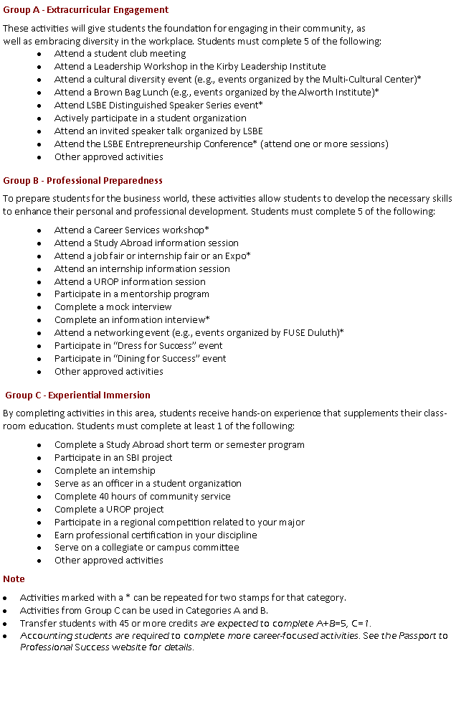

Mission:
Our mission is to facilitate student learning, development, and success through effective and individualized advising & academic services.
LSBE Advising & Academic Services
(218) 726-6594
111A LSBE
lsbesa@d.umn.edu
https://lsbe.d.umn.edu/advising/advising.php
- We provide advising and academic services for undergraduate students.
  - We serve as the initial point of contact for students changing to a major or adding a minor in LSBE.
  - Help students understand Passport Program requirements, advise on selection of activities, and program maintenance.
  - In addition to advising all the new incoming students, we provide complementary advising with our faculty advisors in serving students admitted to candidacy.
  - We serve all students regarding senior credit checks, probation meetings, SAP Appeals, Academic Warning Triage, Midterm Alert Triage, Change of College & Major Declarations, Multi institution registration/Cross Registration, clarifying UMD/LSBE policies and procedures, and assistance with forms and petitions.

Intake Advising Model:
All new incoming students (freshmen and transfer students) are assigned a full-time professional advisor. LSBE uses a complete intake model to ensure all new students receive proactive and intentional advising towards a successful transition to UMD and LSBE. Since all accounting and business majors begin as a pre-major, this model allows us to focus on admission to candidacy requirements and discussions on major selection. Also, students should have a firm understanding of degree requirements and procedures by the time they transition to a faculty advisor. By establishing a relationship with a professional advisor in the Advising & Academic Services (AAS) office, students will have a “go to” person throughout their time at UMD for assistance with policies, procedures, forms, academic standing issues, and other needs that go beyond academic advising & mentorship provided by their assigned faculty advisor. The staff of AAS collaborates with LSBE faculty to meet the advising needs of our students.

Advising & Academic Services Staff

Tracey Bolen
Director

tbolen@d.umn.edu, (218) 726-7520

Vickie Almquist-Minko

Executive Office and Administrative Specialist

valmquis@d.umn.edu, 726-8614

Candy Furo

Academic Advisor

cfuro@d.umn.edu, (218) 726-8986

Mackenzie Bolf
Executive/Operations Student Services Specialist & Academic Advisor
mbolf@d.umn.edu (218) 726-6594

Kurt Guidinger
Academic Advisor

kguiding@d.umn.edu, (218) 726-8757

Bachelor of Accounting and Bachelor of Business Administration

Lower Division Requirements

I. LOWER DIVISION REQUIREMENTS (60 cr)

Part I. Language and Reasoning Skills (14 credits)
A. Writing and Information Literacy
Writ 1120 College Writing 3 cr

B. Oral Communication and Languages
Comm 1112 Public Speaking 3 cr
OR Comm 1222 Interpersonal Comm
OR college level Foreign Language course
(See LSBE Advising office)

C. Logic and Quantitative Reasoning
Math 1160 Finite, Intro to Calculus 5 cr
OR Math 1296-Calculus I
Econ 2030 Applied Stats for Bus/Econ 3 cr

Part II. Knowledge Domains (25 credits minimum)
A. Natural Sciences (2 designators, 1 lab)
______________________________ 4-5 cr (w/lab)l
______________________________ 3-5 cr

B. Social Sciences
Econ 1022 Principles of Econ:Macro 3 cr
Econ 1023 Principles of Econ:Micro 3 cr

Requirements for Admission to Candidacy (upper division status).
- Cumulative GPA and U of M GPA must be at least 2.60

- LSBE internal GPA and Pre-Major GPA must be at least 2.00
- Completion of (or have remaining classes in progress) all pre-major coursework. The pre-major courses consist of those classes which you see typed out in the left-hand column.

Psy 1003 General Psychology 4 cr

C. Humanities
Blaw 2001 Legal Environment 3 cr
_________________________________ 3-4 cr
D. Fine Arts
_________________________________ 3 cr

Part III. Key Topics
Course used for Global Perspective:
______________________________________
Course used for Cultural Diversity in the US
______________________________________
Course used for Sustainability:
______________________________________

ADDITIONAL PRE-MAJOR REQUIREMENTS
*Acct 2001 Prin Financial Acctg 3 cr
*Acct 2002 Prin Mgmt Acctg 3 cr
FMIS 2201 IT in Business 3 cr
LSBE 2000 Interper./Team Skills 1 cr
UST 1000 UMD Seminar 1 cr
*Grade of C of higher is required in Acct 2001 and
Acct 2002 to be admitted into the accounting major

Non-LSBE Electives to total 60 lower division credits.
__________________________________________
__________________________________________
__________________________________________

